

Practices for Secure Software Report

Table of Contents
Document Revision History 3
Client 3
Instructions 3
Developer 4
1. Algorithm Cipher 4
2. Certificate Generation 4
3. Deploy Cipher 4
4. Secure Communications 4
5. Secondary Testing 4
6. Functional Testing 4
7. Summary 4
8. Industry Standard Best Practices 4

Document Revision History

Version | Date | Author | Comments
1.0 | 06/20/2026 | Rea Pridgett

Client



Instructions

Submit this completed practices for secure software report. Replace the bracketed text with the relevant information. You must document your process for writing secure communications and refactoring code that complies with software security testing protocols.

- Respond to the steps outlined below and include your findings.
- Respond using your own words. You may also choose to include images or supporting materials. If you include them, make certain to insert them in all the relevant locations in the document.
- Refer to the Project Two Guidelines and Rubric for more detailed instructions about each section of the template.

Developer
Rea Pridgett

Algorithm Cipher

SHA-256 is the cryptographic hash algorithm I selected for Artemis Financial's application. A hash algorithm creates a fixed-length value, called a checksum or hash, from input data. The primary purpose of SHA-256 in this project is to verify data integrity. If the original data is modified in any way, even by a single character, the resulting checksum changes completely. This allows the application to detect whether data has been altered during transmission.
SHA-256 is part of the SHA-2 family developed by the National Security Agency (NSA) and standardized by the National Institute of Standards and Technology (NIST). It generates a 256-bit hash value, making it significantly more secure than older algorithms such as MD5 and SHA-1, which are no longer recommended because they are vulnerable to collision attacks.
Unlike encryption, SHA-256 is a one-way hash function. It is not designed to encrypt or decrypt information. Instead, it creates a unique fingerprint of the data that can be used to verify its integrity. Encryption uses either symmetric or asymmetric keys to protect the confidentiality of data. Symmetric encryption uses the same key for encryption and decryption, while asymmetric encryption uses a public key and a private key. Random numbers are commonly used during encryption and certificate generation to create strong keys and improve security. In this project, the self-signed certificate uses asymmetric cryptography for HTTPS, while SHA-256 is used separately to verify that the transmitted data has not changed.
For this project, SHA-256 was implemented to generate a checksum for the unique data string "Artemis Financial - Rea Pridgett." This checksum provides a simple way to verify the integrity of the data while supporting secure communication through the HTTPS-enabled web application.

Certificate Generation
Insert a screenshot below of the CER file.

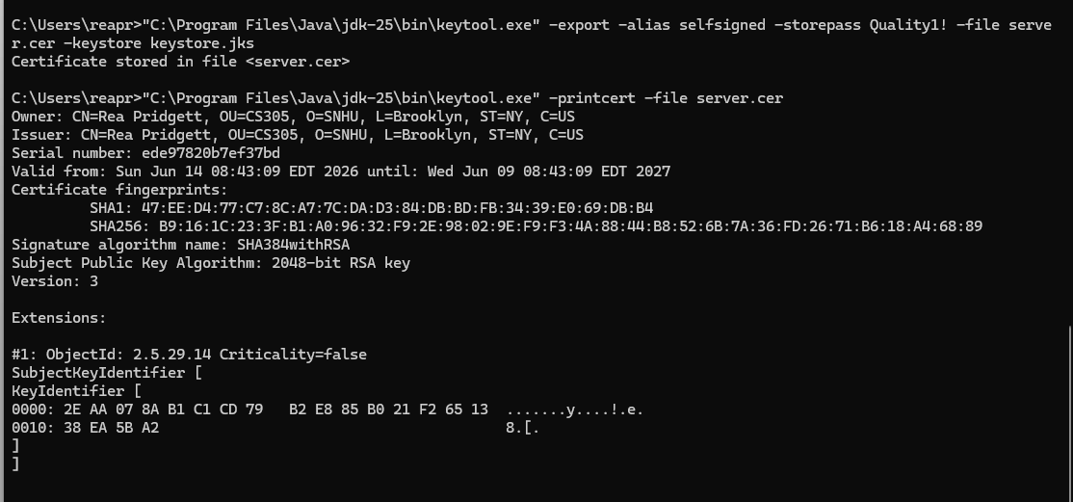

Deploy Cipher
Insert a screenshot below of the checksum verification.

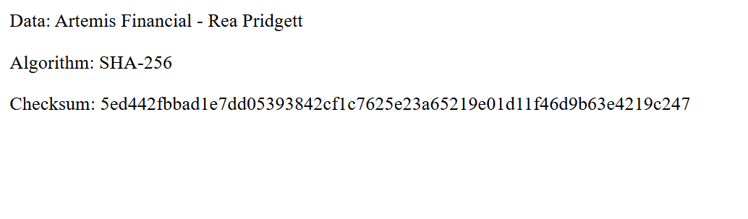

Secure Communications
Insert a screenshot below of the web browser that shows a secure webpage.

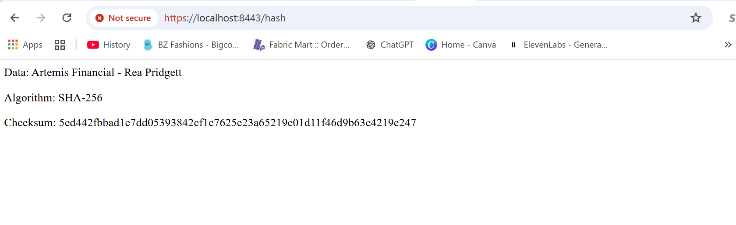

The application was successfully configured to use HTTPS by updating the SSL settings in the application properties file. After compiling and running the application, the server started on port 8443 and the hash page was successfully accessed through the HTTPS connection. This demonstrated that secure communication between the browser and the application was enabled. The browser displays a warning because the application uses a self-signed certificate instead of one issued by a trusted Certificate Authority. This is expected in a local development environment and does not prevent the application from communicating over HTTPS.

Secondary Testing
Insert screenshots below of the refactored code executed without errors and the dependency-check report.

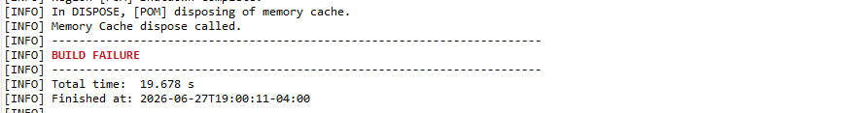
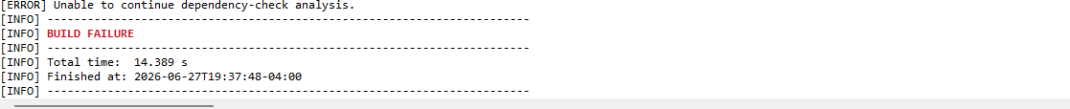

The refactored application was successfully executed after the HTTPS configuration was completed. The Eclipse console confirmed that the application started successfully on port 8443 and that no runtime errors occurred during execution. I also attempted to perform a static dependency analysis using the OWASP Dependency-Check Maven plugin. The application and unit tests completed successfully, but the dependency analysis could not be completed because the National Vulnerability Database (NVD) returned a 403 response while the plugin attempted to retrieve vulnerability data. As a result, the dependency-check report could not be generated. The screenshots included in this section document the successful application execution and the dependency-check error encountered during the analysis.

Functional Testing
Insert a screenshot below of the refactored code executed without errors.

Summary

During this project, I refactored the provided Spring Boot application to improve the security of communications by implementing HTTPS. I generated a self-signed SSL certificate, configured the application to use the keystore, and updated the application properties so the application would run securely on port 8443. I also modified the application to generate a SHA-256 checksum for the Artemis Financial data to help verify data integrity. After making these changes, I successfully compiled and ran the application and verified that the secure communication and checksum functionality worked as expected. As part of the security testing process, I attempted to run the OWASP Dependency-Check plugin to identify known vulnerabilities. I updated the plugin version and configured an NVD API key in an effort to resolve the issue, but the scan could not be completed because the National Vulnerability Database continued to return a 403 response. Although the dependency report could not be generated, this project reinforced the importance of implementing secure communications, verifying data integrity, and using security testing tools throughout the software development process.

Industry Standard Best Practices

This project demonstrated several industry standard best practices for developing secure software. Secure communication was implemented by configuring HTTPS with an SSL certificate, which encrypts data transmitted between the client and the server. A SHA-256 checksum was added to verify data integrity and help detect unauthorized changes to transmitted information. Security testing was also incorporated into the development process by compiling, testing, and attempting to run the OWASP Dependency-Check tool to identify known vulnerabilities in third-party dependencies. Although the dependency-check scan could not be completed because of an external NVD 403 error, updating the plugin and configuring an NVD API key demonstrated the importance of maintaining security tools and keeping software dependencies current. This project reinforced that secure software development requires multiple layers of protection, including encryption, integrity verification, secure configuration, regular testing, and continuous monitoring for vulnerabilities.

